

**American International University-Bangladesh (AIUB)**

Faculty of Science and Technology (FST)

Department of Computer Science (CS)

Undergraduate Program

**Course Code and Title: CSC 3116: Computer Networks**

**Credit: 3**

**Lab Manual:**

**Title: Configuration of Virtual Local Area Network (VLAN) with VLSM**

**Software: cisco packet tracer (version 7.3.0)**

**Network Design:**

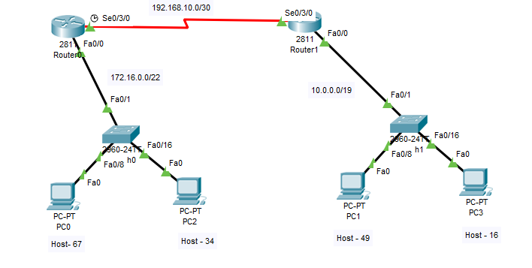

**Question:**

*Default gateway (IP before the broadcast ip), IP of Pc's (First IP of the range)

**Router0**

**Switch0**

Vlan 10- name Faculty (Range f0/2-f0/15)

Vlan -20- name Student (Range f0/16-f0/24)

Trunk port –f0/1

Hostname –AIUB

**Router1**

**Switch1**

Vlan 10- name Faculty (Range f0/2-f0/15)

Vlan -20- name Student (Range f0/16-f0/24)

Trunk port –f0/1

Hostname –NSU

**Solution:**

**Configuration:**

**Switch0**

* Creating vlans and assigning names to the vlans

Switch>en

Switch#config t

Switch(config)#vlan 10

Switch(config-vlan)#name Faculty

Switch(config-vlan)#exit

Switch(config)#vlan 20

Switch(config-vlan)#name Student

Switch(config-vlan)#exit

* Assigning ports to the vlans and trunking f0/1

Switch(config)#int range f0/2- f0/15

Switch(config-if-range)#switchport mode access

Switch(config-if-range)#switchport access vlan 10

Switch(config-if-range)#exit

Switch(config)#int range f0/16- f0/24

Switch(config-if-range)#switchport mode access

Switch(config-if-range)#switchport access vlan 20

Switch(config-if-range)#exit

Switch(config)#int f0/1

Switch(config-if)#switchport mode trunk

Switch(config-if)#switchport trunk allowed vlan all

**Router0**

Router>en

Router#conf t

* Assigning hostname AIUB to Router0

Router(config)#hostname AIUB

* Applying encapsulation and assigning ip to sub-interfaces

AIUB(config)#int f0/0

AIUB(config-if)#no shut

AIUB(config)#int f0/0.10

AIUB(config-subif)#encapsulation dot1q 10

AIUB(config-subif)#ip address 172.16.0.126 255.255.255.128

AIUB(config-subif)#exit

AIUB(config)#int f0/0.20

AIUB(config-subif)#encapsulation dot1q 20

AIUB(config-subif)#ip address 172.16.0.190 255.255.255.192

AIUB(config-subif)#exit

AIUB(config-if)#exit

* Assigning ip to serial interface

AIUB(config)#int s0/3/0

AIUB(config-if)#ip address 192.168.10.1 255.255.255.252

AIUB(config-if)#clock rate 64000

AIUB(config-if)#no shut

* Assigning routing protocol (OSPF with autonomous number 55)

AIUB(config)#router ospf 55

AIUB(config-router)#network 192.168.10.0 0.0.0.3 area 0

AIUB(config-router)#network 172.16.0.0 0.0.0.127 area 0

AIUB(config-router)#network 172.16.0.128 0.0.0.63 area 0

**Switch1**

Switch>en

Switch#conf t

* Creating vlans and assigning names to the vlans

Switch(config)#vlan 10

Switch(config-vlan)#name Faculty

Switch(config-vlan)#exit

Switch(config)#vlan 20

Switch(config-vlan)#name Student

Switch(config-vlan)#exit

* Assigning ports to the vlans and trunking f0/1

Switch(config)#int range f0/2-f0/15

Switch(config-if-range)#switchport mode access

Switch(config-if-range)#switchport access vlan 10

Switch(config-if-range)#exit

Switch(config)#int range f0/16-f0/24

Switch(config-if-range)#switchport mode access

Switch(config-if-range)#switchport access vlan 20

Switch(config-if-range)#exit

Switch(config)#int f0/1

Switch(config-if)#switchport mode trunk

Switch(config-if)#switchport trunk allowed vlan all

**Router1**

Router>en

Router#conf t

Router(config)#int f0/0

Router(config-if)#no shut

* Assigning hostname NSU to Router1

NSU(config)#hostname NSU

* Applying encapsulation and assigning ip to sub-interfaces

NSU(config-if)#int f0/0.10

NSU(config-subif)#encapsulation dot1q 10

NSU(config-subif)#ip address 10.0.0.62 255.255.255.192

NSU(config-subif)#exit

NSU(config)#int f0/0.20

NSU(config-subif)#encapsulation dot1q 20

NSU(config-subif)#ip address 10.0.0.94 255.255.255.224

NSU(config-subif)#exit

* Assigning ip to serial interface

NSU(config)#int s0/3/0

NSU(config-if)#ip address 192.168.10.2 255.255.255.252

NSU(config-if)#no shut

NSU(config-if)#exit

* Assigning routing protocol (OSPF with autonomous number 80)

NSU(config)#router ospf 80

NSU(config-router)#network 192.168.10.0 0.0.0.3 area 0

NSU(config-router)#network 10.0.0.0 0.0.0.63 area 0

NSU(config-router)#network 10.0.0.64 0.0.0.31 area 0